**WEEK-8 GIT**

**Exercise -2: Git – HOL**

1.Step 1- Creating Folder and files:

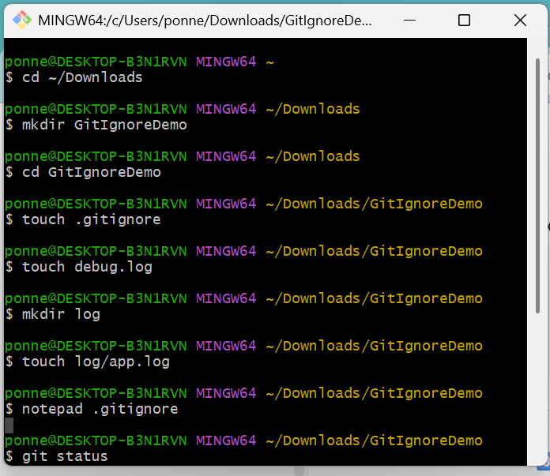

2. Step 2 – Initialize Git Repository  
 and Check Untracked Files

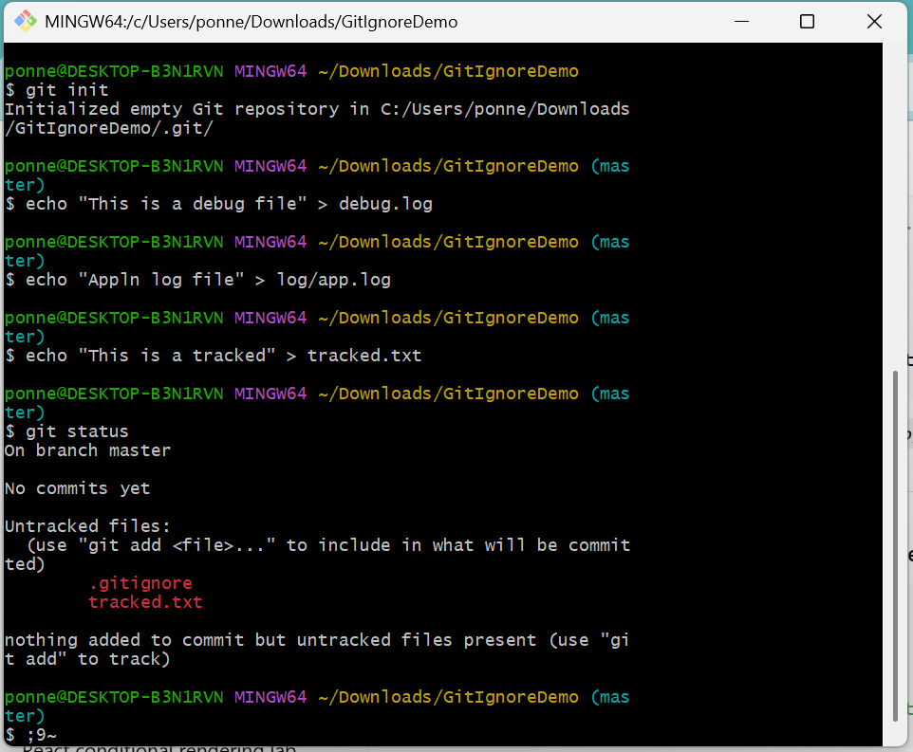

3.Step 3 – Add and Commit .gitignore file:

4. Step 4 – Verify Ignored files and Check Tracked files:

